SQUEEGEE ASSEMBLY NEW STYLE

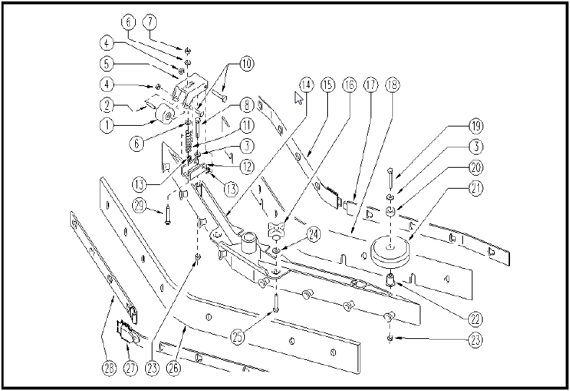
ITEM | SKU | DESCRIPTION | QTY | FROM | TO
16 | E86867 | Squeegee Knob WS20/24 FS28 | 2 | 03/2004
17 | E89283 | Squeegee holder with hook | 1 | 03/2004
18 | E86504 | Front Curved Squeegee Blade WS20/24 | 1 | 03/2004
19 | E86499 | Hex Bolt M6x55 SS | 2
20 | E87834 | Bushing WS20 | 2 | 03/2004
21 | E86451 | AS20 Wheel | 2 | 03/2004
22 | E86560 | spacer | 2 | 03/2004
23 | E86873 | Nut | 4 | 03/2004
24 | E89211 | Washer | 2 | 03/2004
25 | E89212 | Screw | 2 | 06/2004
26 | E86505 | Rear Curved Squeegee Blade WS20/24 | 1 | 03/2004
27 | E86530 | Blade Holder | 1 | 03/2004
28 | E86531 | Blade Holder | 1 | 03/2004
29 | E87930 | Screw M8 x 40 | 2 | 05/2006

